SIMULATING AND ANALYZING PROCESS MANAGEMENT IN AN DOCUMENTATION
Project Title: SIMULATING AND ANALYZING PROCESS MANAGEMENT IN AN
Student Name: Hazel Arana
Course & Section: BSCS – 2
Date: March 14, 2026
Process Illustration (Diagram)
Process States & Transitions:
- New: The process is being created.
  - Transition: Admitted -> Ready
- Ready: The process is waiting to be assigned to a processor.
  - Transition: Scheduler Dispatch -> Running
- Running: Instructions are being executed by the CPU.
  - Transition 1: Interrupt / Time Slice Expired -> Ready
  - Transition 2: I/O or Event Wait -> Waiting
  - Transition 3: Exit -> Terminated
- Waiting (Blocked): The process is waiting for some event to occur (like an I/O completion).
  - Transition: I/O or Event Completion -> Ready
- Terminated: The process has finished execution.
Role of the Process Control Block (PCB): The PCB is a data structure used by the OS to store all the information about a specific process (like its current state, Program Counter, CPU registers, and CPU scheduling info). It acts as the "brain" or "bookmark" for a process. When the CPU switches from one process to another (Context Switch), it saves the current process's data into its PCB and loads the next process's data from its PCB so it can resume exactly where it left off.

CPU Scheduling Simulation
Given Data:
- P1: Arrival = 0 ms | Burst = 5 ms
- P2: Arrival = 1 ms | Burst = 3 ms
- P3: Arrival = 2 ms | Burst = 8 ms
- P4: Arrival = 3 ms | Burst = 6 ms
Formulas used:
- Turnaround Time (TAT) = Completion Time - Arrival Time
- Waiting Time (WT) = Turnaround Time - Burst Time

1. FCFS (First Come First Serve)
Processes are executed strictly in the order they arrive.
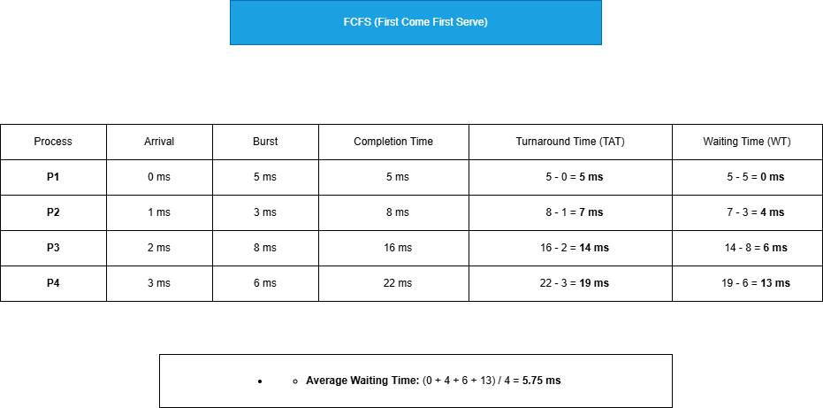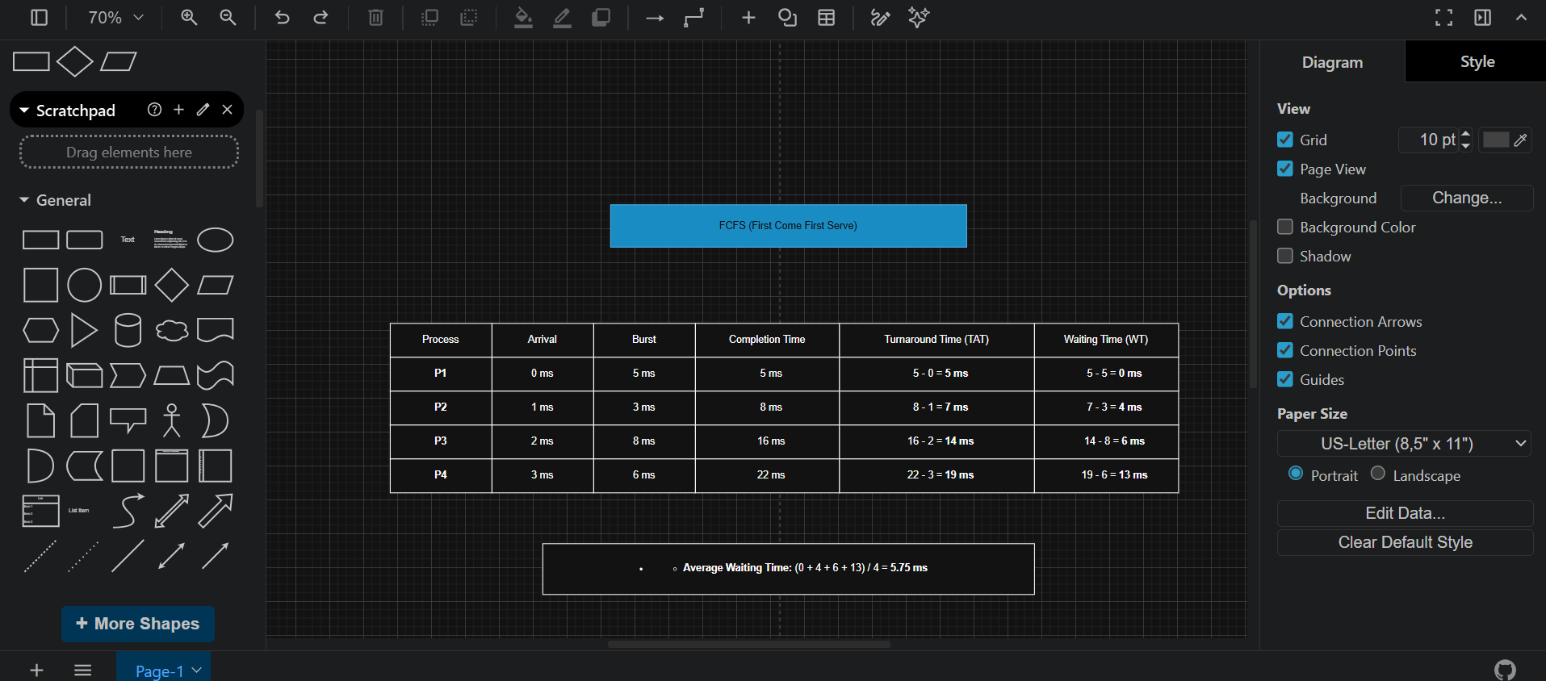

2. SJF (Shortest Job First) - Non-Preemptive
At the time of scheduling, the CPU picks the available process with the shortest burst time.
Gantt Chart: (Note: At T=0, only P1 is available, so it runs first. By T=5, P2, P3, and P4 have arrived. P2 is the shortest, then P4, then P3).
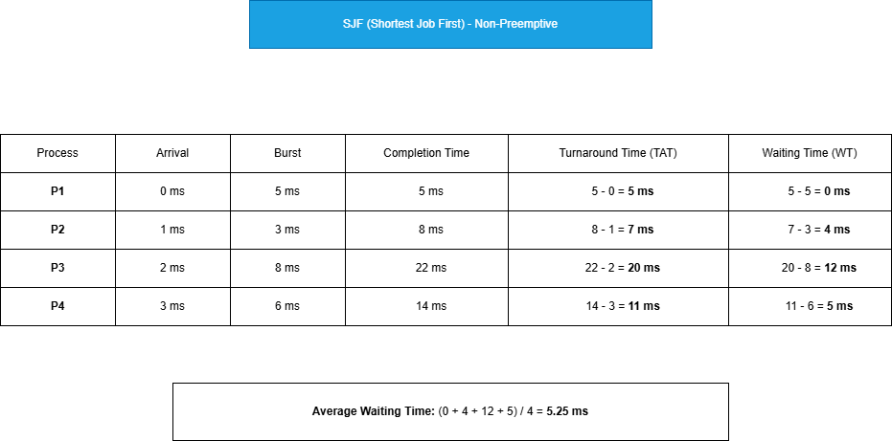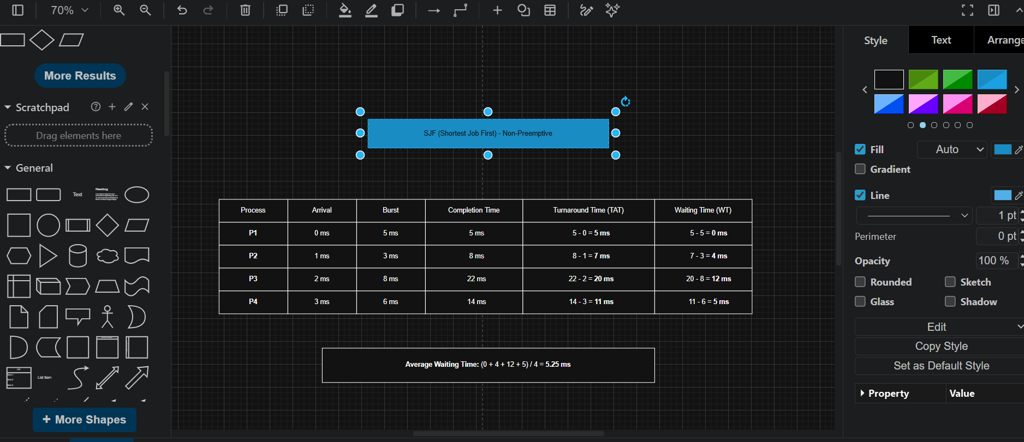

3. Round Robin (Time Quantum = 3 ms)
Processes take turns running for a maximum of 3 ms. If they aren't finished, they go to the back of the Ready Queue.
(Execution breakdown: P1 runs for 3ms. P2 runs for 3ms and finishes. P3 runs for 3ms. P4 runs for 3ms. P1 runs for its remaining 2ms and finishes. P3 runs for 3ms. P4 runs for its remaining 3ms and finishes. P3 runs for its remaining 2ms and finishes).
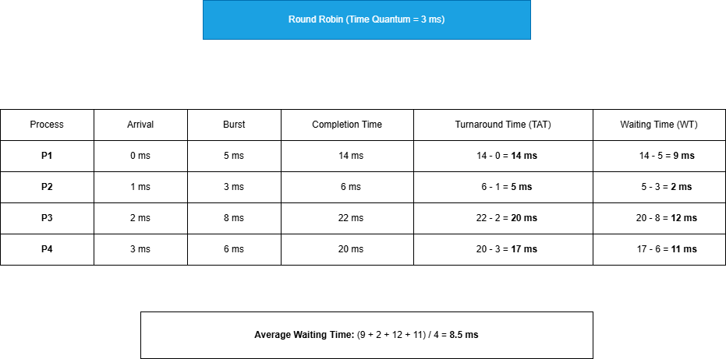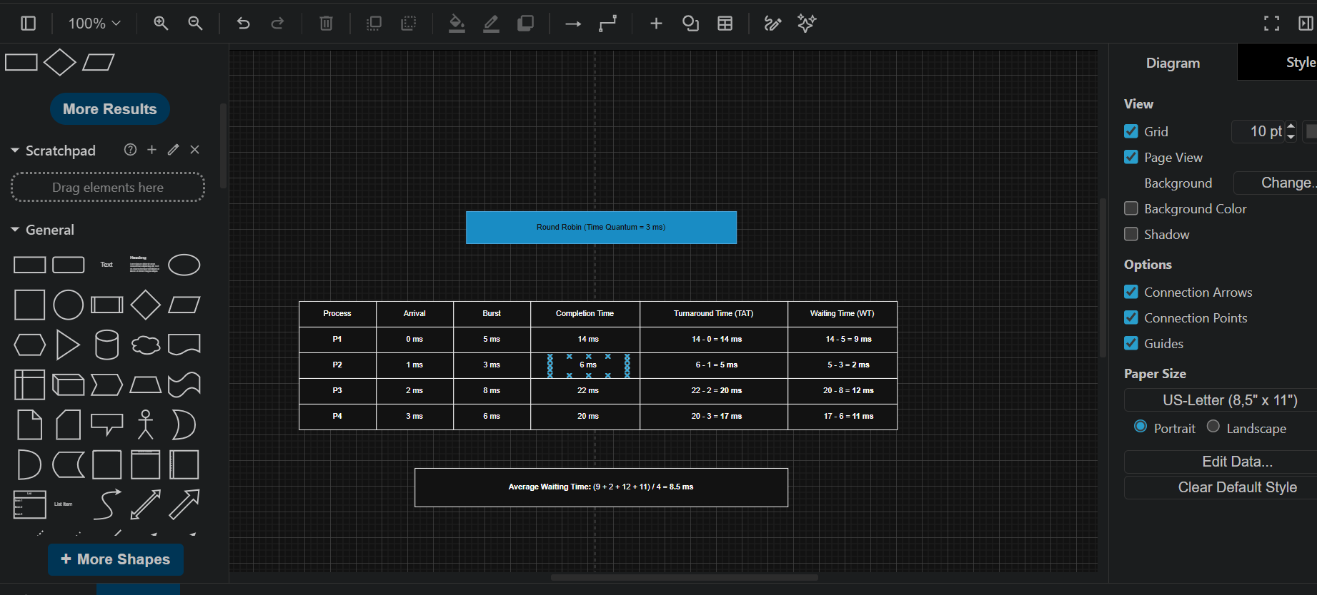

Reflection and Analysis
1. Which scheduling algorithm performed best? Why? Based on the calculations, Shortest Job First (SJF) performed the best because it yielded the lowest Average Waiting Time (5.25 ms), compared to FCFS (5.75 ms) and Round Robin (8.5 ms). By getting the shorter processes out of the way quickly, SJF minimizes the time that short processes spend waiting behind long ones, which mathematically guarantees the minimum average waiting time for a given set of processes.
2. How does PCB help the OS manage processes? The Process Control Block (PCB) acts as the fundamental tracking mechanism for the OS. In preemptive algorithms like Round Robin, the CPU frequently interrupts running processes. The PCB helps by saving the exact state (register values, program counter, and memory limits) of the interrupted process. When it is that process's turn to run again, the OS reads the PCB to resume execution exactly where it left off, ensuring multiple processes can run concurrently without corrupting each other's data.
3. What problems occur if process management is poor? If process management is poorly implemented, several critical issues can arise:
- Starvation: Low-priority or long processes may never get CPU time if shorter or higher-priority processes keep arriving.
- Deadlock: Two or more processes might end up waiting indefinitely for resources held by each other, causing the system to freeze.
- High Latency/Poor Responsiveness: An inefficient scheduler (like FCFS handling a massive burst-time process first) creates the "Convoy Effect," leading to a sluggish user experience and poor overall CPU utilization.

